Project Development Phase
Performance Test

Date | 17 February 2026
Team ID | LVIP2026TMIDSB7385
Project Name | AI Travel Itinerary Generator using Streamlit & Gemini API
Maximum Marks

Model Performance Testing:
S.No. | Parameter | Screenshot / Values
 | Data Rendered | User input data rendered through Streamlit interface.  Fields rendered:  • Destination  • Number of days  • Number of nights  • User interests  • Generate Itinerary button  Data is successfully captured and displayed before model execution.
 | Data Preprocessing | Input preprocessing handled in application logic:  • Destination text cleaned (trim spaces)  • Numeric validation for days and nights  • Empty input checks  • Structured prompt formatting before API call  Ensures valid prompt is sent to Gemini model.
3. | Utilization of Filters | User preference filters applied via prompt constraints:  • Destination filter  • Duration filter (days/nights)  • Interest-based filtering  • Day-wise plan structuring  Model output varies correctly based on filters.
4. | Calculation fields Used | No Tableau/BI calculation fields used.  Instead, dynamic prompt variables are calculated:  • Day-wise itinerary segmentation  • Activity grouping per day  • Interest-based recommendation logic
5. | Dashboard design | 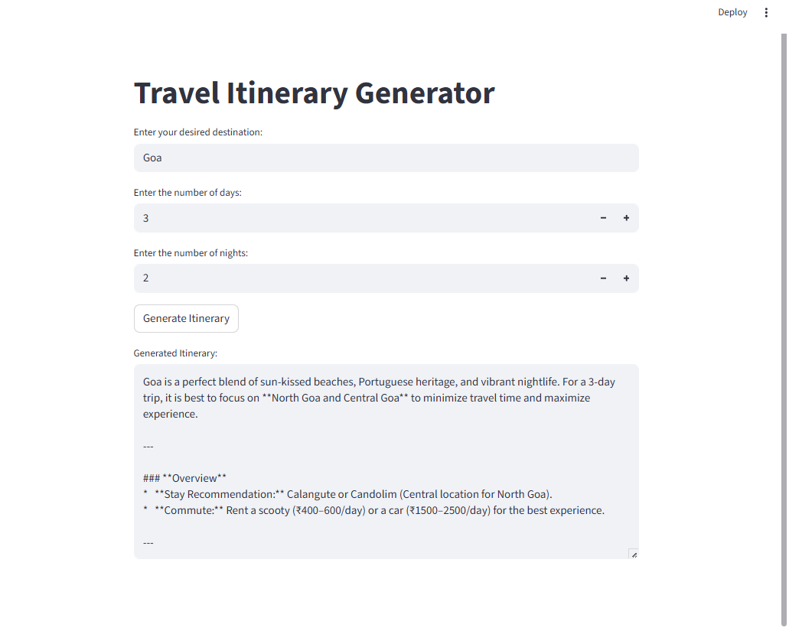
6 | Story Design | Generated itinerary acts as structured AI story output.  Design includes:  • Day-by-day narrative  • Activities + food + travel tips  • Logical flow of trip  • Readable structured format  